Elias White

MA/CSSE 490

Dr. Shibberu

Preliminary Results

Overview:

So far I believe I am on the right track. Because this project is mostly concerned with exploring the destination points of Rose-Hulman students post-graduation, and because this exploration is primarily visual, I’ve been trying out different ways to express the information. I’ve been doing this by location (Distance from Rose-Hulman), by major, and by decision (was the job eventually accepted or rejected). I also have data about salaries so I’m looking into how money makes difference in final location.

I’ve shown you some of the pictures and maps I’ve generated so far. There are too many to show them here, but here’s an interesting one that I don’t think you’ve seen yet:

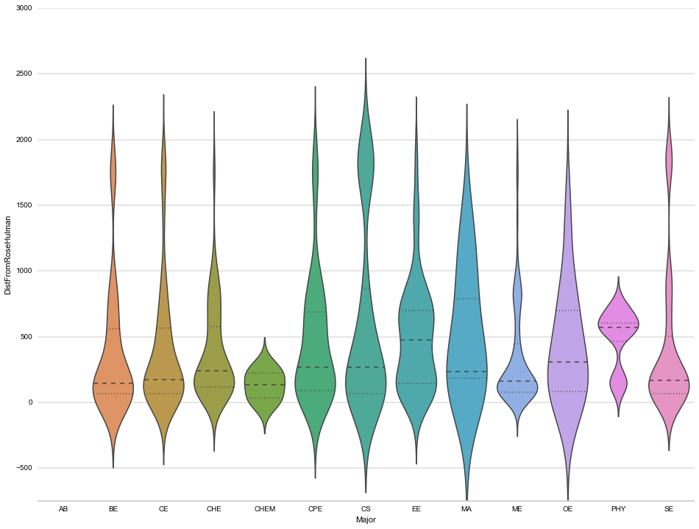

This is a violin plot of Majors versus distance from Rose-Hulman. I’m still exploring, but so far the results have been pretty exciting.

My goal with the project, as always, is to continue exploring the veracity of this:

”Indiana finds itself on a list envied by none: The Wall Street Journal’s “The Worst States for Keeping College Grads.” … Indiana is still one of the states suffering the most from ‘brain drain,’… Only about 30 percent of RHIT’s graduates stay in Indiana. Kevin Hewerdine, the school’s career services director, told local television station WTHI 10 the state needs more employers: ‘Indiana companies do a fabulous job. They pay well, and for our students that want to stay in Indiana, it's a great choice. Unfortunately there's just not enough of them.’” (from World mag, with similar articles in the Washington post, etc.)“

I plan on continuing to do this by exploring the location of all the rejected jobs and the salaries of students staying in Indiana versus those going to other locations.